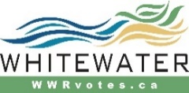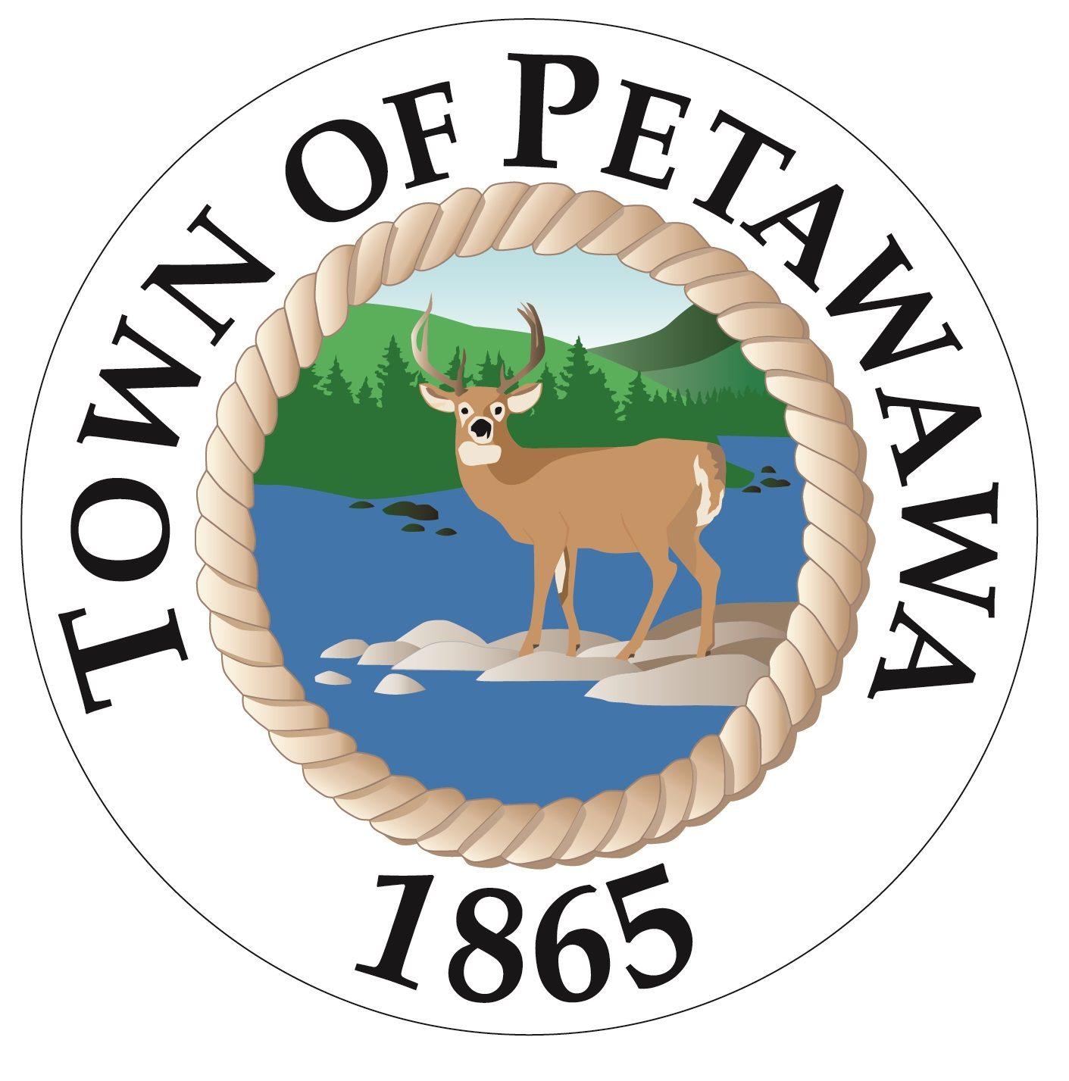

Notice of Nomination for Office
Municipal Elections Act, 1996 (s.32)
Notice is hereby given to the Municipal Electors of the Township of Laurentian Valley, City of Pembroke Town of Petawawa and Township of Whitewater Region that nomination papers for the 2022 Municipal Election may be filed in person or by an agent with the Returning Officer during regular business hours between May 2, 2022 and August 18, 2022 and between 9 am and 2 pm on August 19, 2022 (Nomination Day). The Nomination Form must be accompanied by the filing fee: $200.00 for the Office of Mayor and $100.00 for all other offices. Payment may be made by cash, debit, certified cheque, or money order. There is a new requirement that each Nomination (excluding School Board Trustee candidates) be endorsed by at least 25 eligible electors. Individuals endorsing the candidate must sign a declaration stating they are eligible to vote in the municipality on the day they signed the endorsement.
Registration papers for third party advertisers must be signed by a representative and may be filed in the Office of the Clerk in person or by any agent during regular business hours from May 2, 2022 up to and including October 21, 2022. Registration papers along with a Declaration of Qualification must be certified by the Clerk before such entity becomes a Certified Third Party Advertiser.

Municipal Offices for Which Persons May Be Nominated:
Township of Laurentian Valley | City of Pembroke | Township of Whitewater Region | Town of Petawawa
Mayor - 1  Reeve - 1  Councillor - 5  Returning Officer–  Dean Sauriol  460 Witt Road  Pembroke, ON  (613) 735-6291  www.lvtownship.ca | Mayor - 1  Councillor - 6  Returning Officer-  Heidi Martin  1 Pembroke Street East  Pembroke, ON  (613) 735-6821  www.pembroke.ca | Mayor - 1  Deputy Mayor - 1  Councillor - 5  Returning Officer-Carmen Miller  44 Main Street  Cobden, ON  (613) 646-2282  www.wwrvotes.ca | Mayor – 1  Councillor – 6  Returning Officer – Colin Howard  111 Victoria Street  Petawawa On  (613) 687-5536  www.petawawa.ca

School Board Offices for Which Persons May Be Nominated:
 | Township of Laurentian Valley | City of Pembroke | Township of Whitewater Region | Town of Petawawa
English Public School Trustee | 1  Submit Nomination Form to Laurentian Valley Township | 1  Submit Nomination Form to City of Pembroke | 1  Submit Nomination Form to Whitewater Region Township | 1  Submit Nomination Form to Town of Petawawa
English Catholic School Trustee | 1  Submit Nomination Form to Laurentian Valley Township | 1  Submit Nomination Form to City of Pembroke | 1  Submit Nomination Form to Town of Renfrew | 1  Submit Nomination Form to Town of Petawawa
French  Public  School Trustee | 1  Submit Nomination Form to Town of Petawawa | 1  Submit Nomination Form to Town of Petawawa | 1  Submit Nomination Form to Town of Petawawa | 1  Submit Nomination Form to Town of Petawawa
French Catholic School Trustee | 1  Submit Nomination Form to City of Petawawa | 1  Submit Nomination Form to Town of Petawawa | 1  Submit Nomination Form to City of Petawawa | 1  Submit Nomination Form to Town of Petawawa
For further information, contact the appropriate Returning Officer or municipality.
Dated this 25th day of April 2022
This is a joint notice published by the Clerks of the municipalities listed above.

