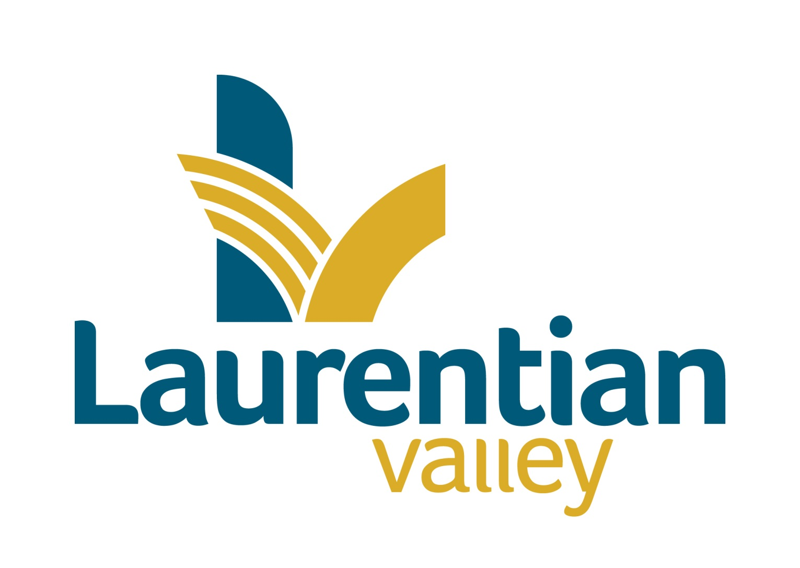

Drinking water system Report

TO: | CAO, Council & Public Works Manager
FROM: | Brad Faught, Quality Management System Representative
DATE: | January 26, 2025
SUBJECT: | 2025 Annual Report

Background

Laurentian Valley Water Works manages just over 14 kilometres of water main and branch lines in the Township. Laurentian Valley Water Works received its Certificate #2893 as a Water Distribution System Class 1 in November of 2000. On May 31, 2011 Drinking Water Works Permit 192-201 and License Number 192-201 was issued by the Ministry of Environment for the Laurentian Valley Distribution System. On November 26, 2025 the License & Permit were renewed. The Drinking Water System Information number for Laurentian Valley Water Works is W260007465. This is the 2025 Annual and Summary Report as required by O.Reg 170/03 as amended.

Laurentian Valley Township has a water servicing agreement with the City of Pembroke. The water is purchased from the City and distributed throughout certain parts of Laurentian Valley. The City of Pembroke treats and tests the water at the Water Purification Plant located on Riverside Drive and tests the water in their distribution system. Laurentian Valley tests the water in its distribution system. The City provides an Annual & Summary Report to the Municipality as required by O.Reg 170/03.

This report and the Certificates of Analysis are available to the general public at the front counter of the Municipal Office at 460 Witt Road during office hours and on the Municipal website. Information on the City Water Works can be accessed at www.pembroke.ca .

Ownership

Laurentian Valley Water Works is owned by the Corporation of the Township of Laurentian Valley.

Operating Authority

Laurentian Valley Water Works is operated by the Corporation of the Township of Laurentian Valley.

Sampling and Testing

The weekly water samples were sent to Caduceon Laboratories Incorporated in Ottawa for analysis. Caduceon is an ODWS Accredited laboratory. The results of the analysis are emailed to the Municipality. The following chart is a summary of those test results.

Analysis for the period of January 1, 2025 - December 31, 2025
Parameter Tested | MAC,  IMAC or  Standard | # of  Samples | # of Adverse  Results | Normal  Range | Note #
E, Coli | Nil | 114 | 0 | Absent
Total Coliforms | Nil | 114 | 0 | < 1/100ml
Heterotrophic Plate Count | 500 CFU/ ml | 30 | 0 | <2 CFU/ml - 10 CFU/ml
Residual Chlorine | .05 mg/ml | 385 | 0 | 0.05 - 1.12 mg/l
Trihalomethanes | 0.10 mg/liter | 4 | 0 | .111 mg/liter
Haloacetic Acid | 0.08 | 4 | 0 | .0595 mg/l
alkalinity - distribution |  | 4 | 0 | 29 - 36mg/l
pH – distribution |  | 4 | 0 | 6.50 – 7.31

In 2025, the municipality paid Caduceon $7,401.47 for laboratory services.

Complaints
There were no complaints filed in 2025.

Staffing & Training
Laurentian Valley Waterworks has 3 operators certified for Water Distribution 1. There is also one Operator-In-Training who successfully passed the level 1 water and wasetwater exam and is in the process of filing for their certificate. In 2025, operators attended the following continuing education courses: Performing Inspection and Maintenance on Fire Hydrants, Maintenancefest, Mandatory Certificate Renewal Course and the Eastern Ontario Waterworks Association Conference as well as New Watermain Commissioning course.

Construction

There was a new service connection line installed to a commercial property on Robinson Lane.
A new residential service line was initialized to a residence on Roy St W.

Maintenance
The hydrants and valves were exercised in the second and fourth quarters, as per the operational plan.
January 9, 2025 watermain break on Roy Street East.
January 11, 2025 watermain break on Roy Street East
February 4, 2025 watermain break on Lorne Street West where a coupler failed
Two residential water service calls to turn water off were completed
Two malfunctioning water meters were replaced by staff
A valve box was repaired on Glen Street
A Curb box was repaired on Glen Street
In 2025 the Works department completed 184 locate requests (2024 was 281), of which 82 identified were water lines to be marked.

Ministry of the Environment, Conservations and Parks
MECP inspection is slated for the second week in February, 2026

Drinking Water Quality Management System

The External Audit is scheduled for April, 2026.

Asset Management and Financial Plan

Financial Plan was updated and required to apply for our new water license.

Accreditation & Licensing

The Water Works continues to be accredited with NSF, the current accreditation expires in June of 2027.

Summary

In 2025, there were two adverse samples for THM’s. The water works purchased 304,473 cubic meters of water from the City of Pembroke (2024 was 306,331 m3). This was a slight increase in volume from the last 5 year average namely due to a warmer summer and fall. Other factors included flushing activites to reduce the THM’s and HAA’s as well as increasing chlorine residuals in the east end line.

Respectfully Submitted
Township of Laurentian Valley

“Original Signed”

Brad Faught
Quality Management System Representative

Five year water consumption statistics (Cubic Meters)

 | 1st Quarter | 2nd Quarter | 3rd Quarter | 4th Quarter | Total | % Deviating from Average
2021 | 67,778 | 73,711 | 62,385 | 70,986 | 274,860 | -6.25
2022 | 65,234 | 74,449 | 83,356 | 67,043 | 290,082 | -1.058038638
2023 | 66,409 | 81,098 | 73,316 | 69,553 | 290,376 | -0.957760315
2024 | 64,778 | 87,425 | 88,247 | 65,881 | 306,331 | 4.484214691
2025 | 63,038 | 76,124 | 98,657 | 66,454 | 304,273 | 3.782266426
5 year average | 65,447 | 78,561 | 81,192 | 67,983 | 293,184

Acronyms

MECP – Minstry of Energy, Conservation and Parks
ODWS – Ontario Drinking Water Standards
MAC – Maximum Acceptable Concentration
IMAC – Interim Maximum Acceptable Concentration
OJT – On Job Training
THM – Trihalomethanes
HAA – Haloacetic Acid

