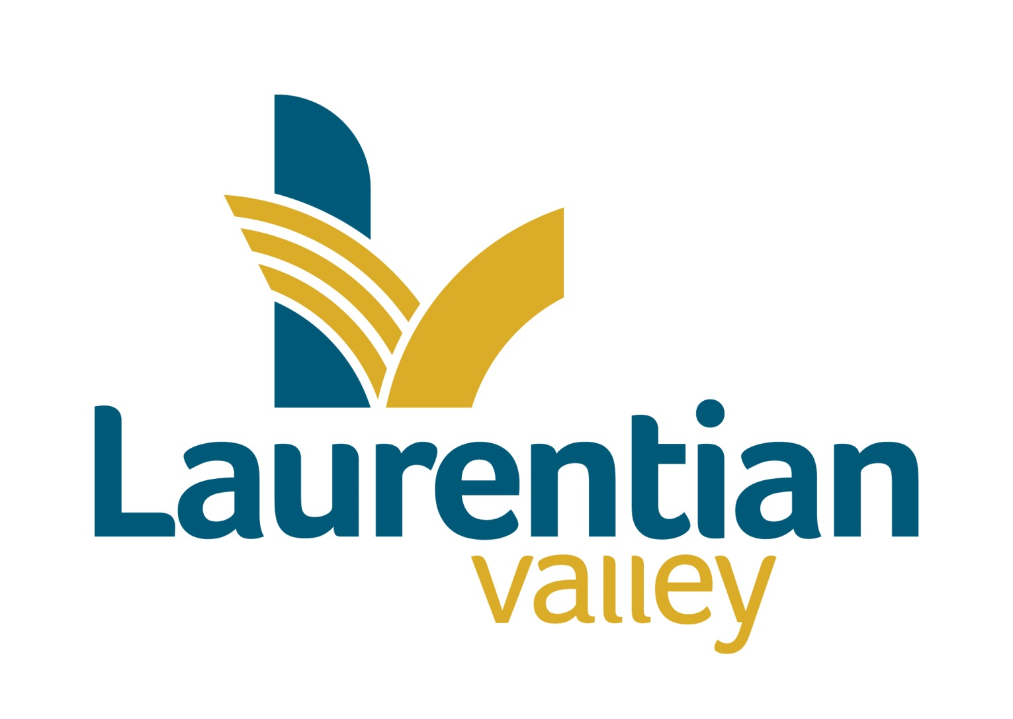

**Drinking water system Report**

|  |  |
| --- | --- |
| **TO:** | CAO, Council & Public Works Manager |
| **FROM:** | Brad Faught, Quality Management System Representative |
| **DATE:** | February 4, 2025 |
| **SUBJECT:** | 2024 Annual Report |

**Background**

Laurentian Valley Water Works manages just over 14 kilometres of water main and branch lines in the Township. Laurentian Valley Water Works received its Certificate #2893 as a Water Distribution System Class 1 in November of 2000. On May 31, 2011 Drinking Water Works Permit 192-201 and License Number 192-201 was issued by the Ministry of Environment for the Laurentian Valley Distribution System. On February 8, 2021 the License & Permit were renewed. The Drinking Water System Information number for Laurentian Valley Water Works is W260007465. This is the 2024 Annual and Summary Report as required by O.Reg 170/03 as amended.

Laurentian Valley Township has a water servicing agreement with the City of Pembroke. The water is purchased from the City and distributed throughout certain parts of Laurentian Valley. The City of Pembroke treats and tests the water at the Water Purification Plant located on Riverside Drive and tests the water in their distribution system. Laurentian Valley tests the water in its distribution system. The City provides an Annual & Summary Report to the Municipality as required by O.Reg 170/03.

This report and the Certificates of Analysis are available to the general public at the front counter of the Municipal Office at 460 Witt Road during office hours and on the Municipal website. Information on the City Water Works can be accessed at [www.pembroke.ca](http://www.pembrokeontario.com) .

**Ownership**

Laurentian Valley Water Works is owned by the Corporation of the Township of Laurentian Valley.

**Operating Authority**

Laurentian Valley Water Works is operated by the Corporation of the Township of Laurentian Valley.

**Sampling and** **Testing**

The weekly water samples were sent to Caduceon Laboratories Incorporated in Ottawa for analysis. Caduceon is an ODWS Accredited laboratory. The results of the analysis are emailed to the Municipality. The following chart is a summary of those test results.

**Analysis for the period of January 1, 2024 - December 31, 2024**

|  |  |  |  |  |  |
| --- | --- | --- | --- | --- | --- |
| Parameter Tested | MAC,  IMAC or  Standard | # of  Samples | # of Adverse  Results | Normal  Range | Note # |
| E, Coli | Nil | 116 | 0 | Absent |  |
| Total Coliforms | Nil | 116 | 0 | < 1/100ml |  |
| Heterotrophic Plate Count | 500 CFU/ ml | 39 | 0 | <2 CFU/ml - 154 CFU/ml |  |
| Residual Chlorine | .05 mg/ml | 453 | 0 | 0.07 - 1.24 mg/l |  |
| Trihalomethanes | 0.10 mg/liter | 4 | 0 | .0785 mg/liter |  |
| Haloacetic Acid | 0.08 | 4 | 0 | .0472 mg/l |  |
| alkalinity - distribution |  | 4 | 0 | 36 - 50 mg/l |  |
| pH – distribution |  | 4 | 0 | 6.46 - 7.1 |  |

In 2024, the municipality paid Caduceon $6579.24 for laboratory services.

**Complaints**

There were two complaints in 2024. The first complaint was due to Serratia Marcensus a pink slime around fixtures and the second complaint was of brown water.

**Staffing & Training**

Laurentian Valley Waterworks has 3 operators certified for Water Distribution 1. There is also one Operator-In-Training. In 2024, operators attended the following continuing education courses: Leak Detection and Flow Measurement, Ministry Approvals – why you compliance person drinks (Water of course!), Under Pressure – Working with Pressurized Water, Mastering the flow – Innovative Valve Solutions for Optimal Performance in Water and Wastewater Solutions, Maintaining Water Stability in Distribution Systems, Maintenancefest, Mandatory Certificate Renewal Course and the Eastern Ontario Waterworks Association Conference. All operators are on track to attain their hours to renew their license.

**Construction**

Construction activities included:

Roy Street West water and sewer replacement.

Commissioning of a new water service at the new gas station on Pembroke Street East.

Commissioning of a new water service for two houses on Jean Avenue.

Commissioning of a new water service for a 10plex on Roy Street East.

**Maintenance**

The hydrants and valves were exercised in the second and fourth quarters, as per the operational plan.

There was 9 customer service events in 2024 (2023 was 11).

January 9, 2024 Saddle replacement on Roy Street East.

April 10, 2024 New Water Valve installed on Roy Street West.

December 24, 2024 Watermain break on Willow Drive.

In 2024 the Works department completed 281 locate requests (2023 was 230), of which 137 identified water lines to be marked.

**Ministry of the Environment, Conservations and Parks**

MECP inspector has been sent the paperwork required to proceed with the 2024 audit.

**Drinking Water Quality Management System**

The External Audit was conducted on April 11, 2024. There were no Corrective Actions found. Opportunity for Improvements were completed and revised. Internal Audit was conducted by Kendryck.

**Asset Management** **and Financial Plan**

No changes both are current.

**Accreditation** **& Licensing**

The Water Works continues to be accredited with NSF, the current accreditation expires in June of 2027.

**Summary**

In 2024, there were no adverse samples. The water works purchased 50,386,485gallons of water from the City of Pembroke. This was a slight increase in volume from the last 10 year average.

Respectfully Submitted

Township of Laurentian Valley

***“Original Signed”***

Brad Faught

Quality Management System Representative

**Ten year water consumption statistics**

|  |  |  |  |  |  |  |
| --- | --- | --- | --- | --- | --- | --- |
|  | **1st Quarter** | **2nd Quarter** | **3rd Quarter** | **4th Quarter** | **Total** | **% Deviating from Average** |
|  |  |  |  |  |  |  |
| **2015** | **13,457,180** | **16,916,645** | **16,032,685** | **12,440,670** | **58,847,180** | **18.00412902** |
| **2016** | **11,976,910** | **14,558,170** | **15,791,380** | **12,040,490** | **54,366,950** | **9.020394904** |
| **2017** | **10,709,380** | **11,996,820** | **12,318,240** | **11,742,610** | **46,767,050** | **-6.218886826** |
| **2018** | **12,022,340** | **13,355,100** | **14,025,550** | **12,062,490** | **51,465,480** | **3.202384917** |
| **2019** | **11,904,640** | **12,334,476** | **12,725,130** | **10,507,288** | **47,471,534** | **-4.806254812** |
| **2020** | **10,806,026** | **9,673,730** | **13,064,392** | **11,786,940** | **45,331,088** | **-9.098265059** |
| **2021** | **12,271,468** | **15,380,310** | **14,881,460** | **13,855,050** | **56,388,288** | **13.07358238** |
| **2022** | **11,369,270** | **12,939,300** | **12,195,370** | **11,152,240** | **47,656,180** | **-4.435997506** |
| **2023** | **10,061,194** | **10,676,996** | **12,491,270** | **11,519,530** | **44,748,990** | **-10.26547921** |
| **2024** | **10,257,610** | **13,339,920** | **12,732,786** | **14,491,794** | **50,822,110** | **0.864567155** |
| **10 year average** | **11,483,602** | **13,117,147** | **13,625,826** | **12,159,910** | **50,386,485** |  |

**Acronyms**

MECP – Minstry of Energy, Conservation and Parks

ODWS – Ontario Drinking Water Standards

MAC – Maximum Acceptable Concentration

IMAC – Interim Maximum Acceptable Concentration

OJT – On Job Training