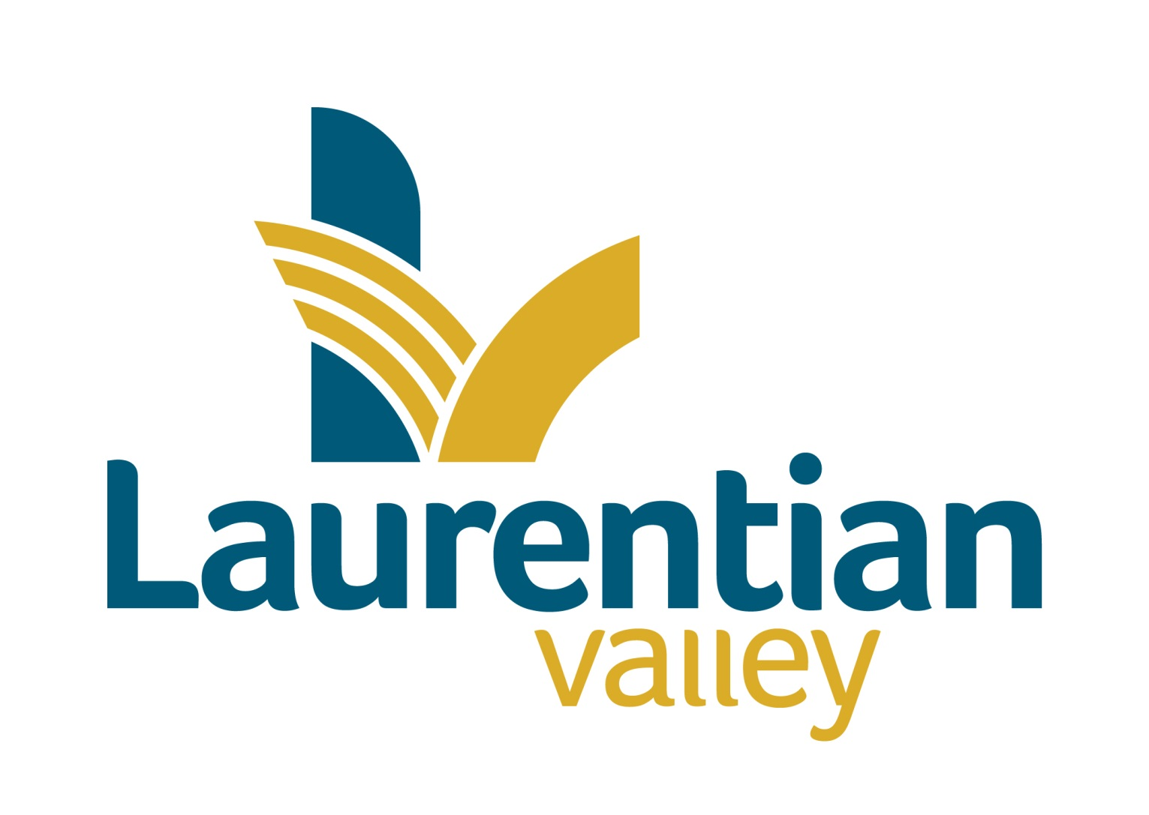

Drinking water system Report

TO: | CAO, Council & Public Works Manager
FROM: | Brad Faught, Quality Management System Representative
DATE: | May 20, 2025
SUBJECT: | 1st Quarterly Report 2025

Background

Laurentian Valley Water Works manages just over 14 kilometres of water main and branch lines in the Township. Laurentian Valley Water Works received its Certificate #2893 as a Water Distribution System Class 1 in November of 2000. On May 31, 2011 Drinking Water Works Permit 192-201 and License Number 192-201 was issued by the Ministry of Environment for the Laurentian Valley Distribution System. On February 8, 2021 the License & Permit were renewed. The Drinking Water System Information number for Laurentian Valley Water Works is W260007465. This is the first report for 2025.

Laurentian Valley Township has a water servicing agreement with the City of Pembroke. The water is purchased from the City and distributed in the Stafford Village area, part of Pembroke Street East and part of Pembroke Street West. The City treats and tests the water at the Pembroke Filtration Plant on Riverside Drive and tests the water in their distribution system. The Municipality tests the water in its distribution system.

This report and the Certificates of Analysis are available to the general public at the front counter of the Municipal Office at 460 Witt Road during office hours. Information on the City Water Works can be accessed at www.pembroke.ca

Strategic Directions Alignment:
Core Values
 | Value for money |  | Professionalism
 | Act with integrity | X | Transparency
Strategic Directions
 | Embrace Rural Identity |  | Invest responsibly in assets & programs
 | Prioritize Communication |  | Enhance active & social living
Mission/Vision/Other

Testing

The weekly water samples were sent to Caduceon Laboratories Inc. in Ottawa for analysis. Caduceon is an ODWS Accredited laboratory. The results of the analysis are emailed to the Municipality. The following chart is a summary of those test results.

Analysis for the period of January 1, 2025 – March 31, 2025
Parameter Tested | MAC,  IMAC or  Standard | # of  Samples | # of Adverse  Results | Normal  Range | Note #
E, Coli | Nil | 28 | 0 | Absent
Total Coliforms | Nil | 28 | 0 | < 1/100ml
Heterotrophic Plate Count | 500 CFU/ ml | 5 | 0 | <2 CFU/ml
Residual Chlorine | .05 mg/ml | 91 | 0 | 0.07 – 1.08 mg/l
Trihalomethanes | 0.10 mg/liter | 1 | 0 | 0.086 mg/liter | 4/4 avg
Haloacetic Acid | 0.05 | 1 | 0 | 0.0447 | 4/4 avg

In the first quarter of 2025, the municipality paid Caduceon $1462.37 for laboratory services (HST included).

Complaints
There were no complaints received during the 1st quarter.

Staffing & Training
Laurentian Valley Waterworks has 1 Water Quality Analyst, 3 operators certified for Water Distribution 1 and one Operator-in-Training.

Maintenance

On January 9, 2025 there was a watermain break on Roy Street East and a repair band was installed to stop the leak.
On January 11, 2025 another watermain break on Roy Street East just east of the previous break on January 9th, 2025.
On February 4, 2025 there was a watermain break on Lorne Street a Robax coupler failed and was replaced. While we were repairing the break, the hydrant was non-operational and suspected to be frozen so it was replaced as well.
There were 3 calls for water to be shut off or turned on during the 1st quarter.
There were 36 locate requests completed in the first quarter, of which 9 were identified water lines to be marked.

Ministry of Environment, Conservation & Parks

MECP conducted their audit in December of 2024. There were two findings in the audit which have been rectified. The audit report is attached.

Drinking Water Quality Management System

The external water audit was conducted on April 15th 2025. Details of the audit are attached to this report.

Summary

In the first quarter of 2025, the water works purchased 38,791 cubic meters of water from the City of Pembroke distributed to homes and businesses. There were no adverse water quality events in the first quarter.

Respectfully Submitted
Township of Laurentian Valley

“Original Signed”

Brad Faught
Quality Management System Representative

Acronyms

ODWS – Ontario Drinking Water Standards
MAC – Maximum Acceptable Concentration
IMAC – Interim Maximum Acceptable Concentration

